Obtaining transconjugant strains for bacteria-rice interaction studies
Ionel Hernández¹, María Caridad Nápoles², Federico Battistoni³, Elena Fabiano⁴
(1, 2). National Institute of Agricultural Science, Plant Physiology and Biochemistry Department. Carretera a Tapaste Km 3 y ½, San José de las Lajas 32700, Mayabeque, Cuba.
(3, 4). Clemente Estable Biological Research Institute, Microbial Biochemistry and Genomics Department. Avenida Italia 3318, Montevideo 11600, Uruguay.
- Dr. C. Investigador Agregado (60 % participación). ionel@inca.edu.cu, https://orcid.org/0000-0002-5760-816X
- Dr. C. Investigador Titular (30 % participación). tere@inca.edu.cu, https://orcid.org/0000-0003-1413-1717
- Dr. C. (5 % participación) febattist@gmail.com, https://orcid.org/0000-0002-5648-1304
- Dr. C. (5 % participación) elena.fabiano@gmail.com, https://orcid.org/0000-0003-2868-6393
Abstract
The tagging method with genes coding for a fluorescing protein is a novelty tools for plant-bacteria interaction studies. The objective of this work was to obtain effective transconjugant strains for the study of plant-bacteria interaction. The construction of transconjugant bacteria containing the plasmid pHC60 was carry out by triparental mating with two Escherichia coli strains and two strains isolated from Cuban rice cultivars. An inoculation assay with rice plant and transconjugant bacteria was carry out to demonstrate that transconjugant strains obtained were effectives to plant-bacteria interaction studies. Two transconjugant strains containing gfp gene were obtained which was confirmed since fluorescent colonies were showed in culture medium with tetracycline and 5-nitrofurantoine and exposed to UV light. The multiplication dynamics of wild type and transconjugant strains don’t showed differences in the growth specific velocity between both strains. Two transconjugant strains were showed colonizing rice root and one of them as a putative endophyte.
Key words: Rhizobium, grass, endophytes, green fluorescent protein
Introduction
Different tools have been development to study deeply the bacteria-plant association such as omic sciences, serological techniques coupled with confocal laser scanning microscopy and the method of the tagging with genes coding for a fluorescing protein (1,2,3). These tools have allow explore the rhizobia-rice interaction and understand the differences with the interaction of these bacteria with legume plants about infection process, and bacteria distribution inside the vegetable tissue (4,5).
Recently, it was report in Cuba for first time that Rhizobium is “true endophyte” of rice which was demonstrated by inoculation assays with a transconjugant strain which was visualized by confocal microscopy (6). Although in this work transconjugant cells containing gfp gene which coding for a green fluorescent protein (stain Rpd16pHC60 containing the plasmid pHC60) were showed colonizing the tissues of rice plant INCA LP-5, no evidence of the obtaining of these bacteria was shown, even from other strains that have showed promoting growth activity in rice plant cultivar INCA LP-5. Taking into account the above, the objective of this work was to obtain effective transconjugant strains for plant-bacteria interaction studies.
Materials and methods
Bacteria used in this work and their main characteristics are listed in Table 1.
Table 1 Strains used in this work
Strain | Main features | Reference
Rhizobium sp. Rpr11 (MT387213) | Strain isolated from rice rhizosfere cv. INCA LP-5, characterized account plant growth promoting trait and promoted the rice growth. | (6)
Pseudomonas sp. S5-38 (MT808971) | Strain isolated from rice seed cv. INCA LP-5 | Bacteria collection of National Institute of Agricultural Science (INCA)
Rhizobium sp. 5P1 (MT759831) | Strain isolated from rice rhizosphere cv. INCA LP-7 that promoted the rice growth in controlled, greenhouse and field conditions. | (7)
Rhizobium sp. Rpd16pHC60 | Rpd16 strains containing the plasmid pHC60 | (6)
Escherichia coli DH5α | supE44⊗lacU169(⎞80lacZ⊗M15)hsdR17 recA1 endA1 gyrA96 thi-1 | (8)
Escherichia coli pRK2013 | ColE1 replicon with RK2 tra genes. Used for mobilizing incP and incQ plasmids (Km^{r}) | (9)
*Fractions in parentheses represent the access number of consensus sequences deposited in GenBank
All they belong to bacteria collections of the National Institutes of Agricultural Science, Cuba. Three of them; Rhizobium sp. Rpd16, Rhizobium sp. Rpr11 and Rhizobium sp. 5P1 were studied deeply in previous investigations (6,7). The strain Pseudomonas sp. S5-38 is less studied and it is putative endophytic bacteria of rice seed cv. INCA LP-5.
Construction of transconjugant bacteria containing the plasmid pHC60
Transconjugant bacteria of the strains Rpr11, 5P1 and S5-38 containing the plasmid pHC60, were obtained according the methodology reported previously with the strain Rpd16. Similarly, the strains E. coli DH5 α(pRK2013) and E. coli DH5 α(pHC60) were used and triparental mating was carry out. The process efficacy was checking cultured the transconjugants strains on Tryptone-yeast extract (TY) with tetracycline (10 μg mL⁻¹) and 5-nitrofurantoine (50 μg mL⁻¹), incubated at 30 °C during 48 h. The plates were exposed to UV and fluorescent colony were cultured in the same medium and maintained at 4 ºC (6).
Several multiplication dynamics were carried out to check out if the plasmid presence affects the strains Rpd16 and Rpr11 growth. The strains were incubated in a thermostated shaker (HEIDOLPH-UNIMAX-2010, Schwabach, Germany) at 150 rpm and 30 ºC for 24 h. The OD (λ = 600 nm) was measured every 2 h for 30 h. Five replicates of each strain were used.
Bacteria-rice plant interaction
An inoculation assay was carried out to study the bacteria-rice interaction. Here, only the transconjugants Rpd16pHC60 and Rpr11pHC60 were used. One hundred microliters of the strains inoculants (10⁸ CFU mL⁻¹) were used to inoculate pre germinated rice seed cv. INCA LP-5. The seedlings were maintained in half-strength Hoagland’s plant growth medium and incubated in controlled conditions during 72 hours post inoculation (hpi). The roots were cut, inmoviliced (agarose 4%) and sectioned and then the bacterial colonization of seedling roots was visualized in a confocal laser microscope (Zeiss, LSM 800 AiryScan, Jena-Germany) as was reported previously (6).
Statistical analysis
Absorbance values obtained in the multiplication dynamics were subjected to the normality test (Bartlett test) and homogeneity of variance (Kolmogorov-Smirnov test). A simple classification analysis of variance was applied with the Tukey HSD mean comparison tests for p<0.05. The Statgraphic Plus program version 5.0 was used for statistical processing of the data and Microsoft Excel 2010 for its representation.
Results and discussion
Previously, it was demonstrate that strain Rhizobium sp. Rpd16 is endophyte of rice, since it was showed in intercellular spaces of the parenchyma of root and leaf sheath by confocal microscopy. For this, a transconjugant strain containing the plasmid pHC60 was obtained (Rpd16pHC60) (6). Similarly, the triparental mating with E. coli strains allowed obtain strains containing this plasmid. It was confirmed when the strains Rpr11pHC60, 5P1pHC60 and S5-38pHC60 grown in TY medium with tetracycline and 5-nitrofurantoine, and fluorescent colonies were showed in presence of UV light (Figure 1).
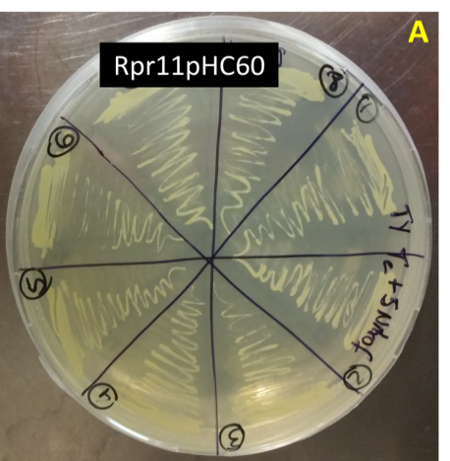 | 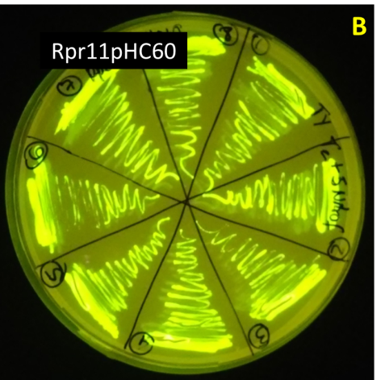

Figure 1. Transconjugant strain Rpr11 (Rpr11pHC60) containing the plasmid pHC60 in TY medium with tetracycline (10 μg mL⁻¹) and 5-nitrofurantoine (50 μg mL⁻¹), and exposed to white light (A), UV light (B).
The multiplication dynamics showed some differences in the growth between the wild type and transconjugant strains. However the OD of four wild type strains and their transconjugant strains were similar at the end of experiment (Figure 2). Thus, the effect of plasmid pHC60 in the transconjugant strains growth could be not significative.
No significative differences were showed in the strain Rpd16pHC60 growth and its wild type strain in all evaluation moments. This behavior was also reported when the effect of GFP-tagging on nitrogen fixation of an endophytic diazotrophic strain of Paenibacillus polymyxa was studied (10). Probably, it is other reason to think why the plasmid pHC60 did not affect the ability of strain Rpd16 to colonize plant tissues, as was reported previously (6). In the other three strains, only significative differences were showed at 12-14 h in S5-38/S5-38pHC60, 10-20h in Rpr11/Rpr11pHC60 and 5P1/5P1pHC60. In these moments, the transconjugant strains S5-38pHC60 and 5P1pHC60 had greater OD than theirs wild type strains.
In the other hand, it is know that in bacteria-plant interaction are distinguished associations with different degrees of complexity and the rhizosphere, phyllosphere and endosphere have been the main sceneries for the study of particularities of this interaction. The knowledge of association levels between bacteria and plants is essential for understand the how the microorganism colonizes the plant which is necessary to design and validate effective’s inoculants in the field (1,2). In order to study the interaction bacteria-plant, rice seedlings cv. INCA LP-5 were inoculated only with the strains Rpd16 pHC60 and Rpr11pHC60. The selection was based on previous studies suggesting that their wild type strains are promising rhizobia to bio-fertilize rice crop (7).

Figure 2. Multiplication dynamics in medium TY of strains S5-38, Rpd16, Rpr11, 5P1 and their transconjugants containing the pHC60 plasmid. The data points and bars represent the means and standard errors of the mean from three replicates at each sampling time (Tukey HSD P<0.05, n = 5). OD: optical density, µ: growth specific velocity. Same letter means not statistically different (Tukey HSD p<0.05).
Although there was already evidence about Rpd16pHC60 strain as a rice endophyte, it was used on this occasion to delve into the forms of association with rice plants and as a comparison model with the Rpr11 strain. Cross sections of rice roots were analyzed by confocal microscopy at 72 hpi and the results showed individual bacterial of the strain Rpd16pHC60 in the intercellular spaces of the cortical root parenchyma, similar to reported previously (Fig. 3a) (6). However, transconjugant cells were also visualized attached to the root hair which was not showed in micrographs reported before (Fig. 3b).
The strain Rpr11pHC60 was localized colonizing the intercellular spaces of root parenchyma. This is new evidence that suggest other strain belonging Rhizobium genus as endophyte of rice cv. INCA LP-5. However, it is necessary to study more deeply the interaction of strain Rpr11 strain with rice to conclude that it is a “true endophyte”. Previously, the study of rhizobia-pinach (Spinacia oleracea) and rhizobia-sugarcane (Saccharum officinarum) interactions was carry out by the method of the tagging with genes coding for a fluorescing protein (11,12). Rice plants cv. INCA LP-5 inoculated with Rpr11 strain showed an increase in the potassium content and root dry weigh in greenhouse conditions (7). Thus, if Rpr11 have an endophytic behavior, it is an attribute that also would allow explaining its plant growth promoting activity.
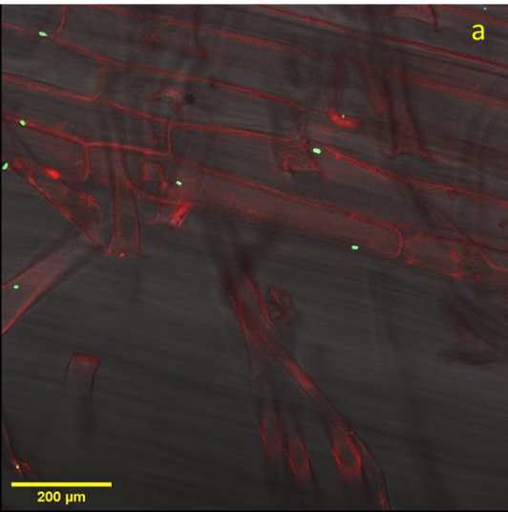 | 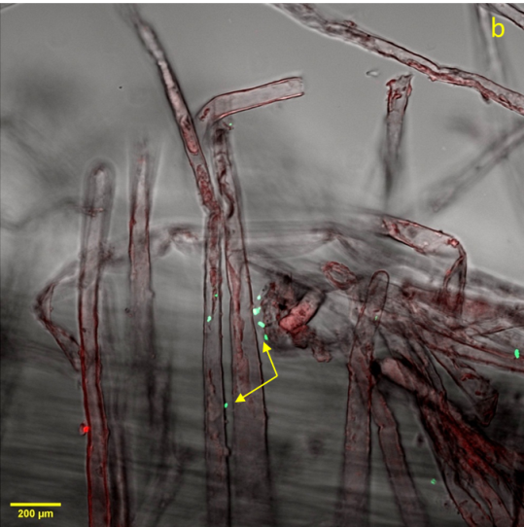 | 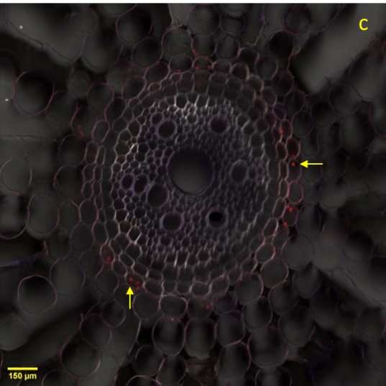
Figure 3. Fluorescence confocal microscopy images showing root tissue sections of 72 h old rice seedlings cultivar INCA LP-5. (a, b) Seedlings inoculated with the strain Rpd16pHC60. Transconjugant cells are displayed in green, red color: autofluorescence of plant tissue. (c) Root cross section of seedlings inoculated with the strain Rpr11pHC60. Transconjugant cells are displayed in red. Yellow arrows: presence of the transconjugant strains.
Conclusions
The employ of transconjugant strains and the confocal microscopy for plant-bacteria interaction studies is an effective and novel tool. Here, three transconjugant strains containing the pHC60 plasmid were obtained and one of these is a putative endophyte of rice cv. INCA LP-5. The fact that the wild type strains used came from of different rice cultivars and association levels with the plant could give us more knowledge about the particularly of their interaction with rice plant.
References
1. Sarhan MS, Hamza MA, Youssef HH, Patz S, Becker M, ElSawey H, et al. Culturomics of the plant prokaryotic microbiome and the dawn of plant-based culture media–A review. Journal of Advanced Research. 2019;19(19):15-27. doi: 10.1016/j.jare.2019.04.002
2. Hartmann A, Fischer D, Kinzel L, Chowdhury SP, Hofmann A, Baldani JI, et al. Assessment of the structural and functional diversities of plant microbiota: Achievements and challenges–A review. Journal of Advanced Research. 2019;19:3-13. doi: 10.1016/j.jare.2019.04.007
3. Geddes, BA, Paramasivan P, Joffrin A, Thompson AL, Christensen K, Jorrin B, et al. Engineering transkingdom signalling in plants to control gene expression in rhizosphere bacteria. Nature communications. 2019;10(1):1-11. doi: 10.1038/s41467-019-10882-x
4. Chen X, Miché L, Sachs S, Wang Q, Buschart A, Yang HY, et al. Rice responds to endophytic colonization which is independent of the common symbiotic signaling pathway. New Phytologist. 2015;208(2):531-543. doi: 10.1111/nph.13458
5. Wu Q, Peng X, Yang M, Zhang W, Dazzo FB, Uphoff N, et al. Rhizobia promote the growth of rice shoots by targeting cell signaling, division and expansion. Plant Molecular Biology. 2018;97(6):507-523. doi: 10.1007/s11103-018-0756-3
6. Hernández I, Taulé C, Pérez-Pérez R, Battistoni F, Fabiano E, Rivero D, et al. Endophytic rhizobia promote the growth of Cuban rice cultivar. Symbiosis. 2021a; 85(2):1-16.
doi: 10.1007/s13199-021-00803-2
7. Hernández I, Pérez-Pérez R, Nápoles MC, Maqueira LA, Rojan O. Rhizospheric rhizobia with potential as biofertilizers from Cuban rice cultivars. Agronomía Colombiana. 2021b; 39(1),26-37. doi: 10.15446/agron.colomb.v39n1.88907
8. Hanahan D. Studies on transformation of Escherichia coli with plasmids. Journal of Molecular Biology. 1983;166(4):557-580. doi: 10.1016/s0022-2836(83)80284-8
9. Ditta G, Stanfield S, Corbin D, Helinsky D. Broad host range DNA cloning system for gram-negative bacteria: construction of a gane bank of Rhizobium meliloti. Proceedings of National Academy of Sciences. 1980;77(12):7347-7351. doi: 10.1073/pnas.77.12.7347
10. Padda KP, Puri A, Zeng Q, Chanway CP, Wu X. Effect of GFP-tagging on nitrogen fixation and plant growth promotion of an endophytic diazotrophic strain of Paenibacillus polymyxa. Botany. 2017; 95(9):933-942. doi: 10.1139/cjb-2017-0056
11. Jiménez-Gómez A, Flores-Félix JD, García-Fraile P, Mateos PF, Menéndez E, Velázquez E, et al. Probiotic activities of Rhizobium laguerreae on growth and quality of spinach. Scientific Reports. 2018;8(1):1-10. doi: 10.1038/s41598-017-18632-z
12. Ferreira NS, Matos GF, Meneses CH, Reis VM, Rouws JR, Schwab S, et al. Interaction of phytohormone-producing rhizobia with sugarcane mini-setts and their effect on plant development. Plant and Soil. 2020; 451(1):221-238. doi: 10.1007/s11104-019-04388-0

